**Abstract:**

Metal Oxide Semiconductor Field Effect Transistors (MOSFETs) and Bipolar Junction Transistors are the two most popular types of transistor (BJT). In the 1960s and 1970s, BJT-based circuits dominated the electronics industry. MOSFETs are now used in the majority of electronic circuits, especially integrated circuits (ICs). The main applications of BJTs include analog circuits (such as amplifiers), high-speed circuits, and power electronics. BJTs and FETs differ primarily in two ways. The first is that while BJTs are current-controlled devices, FETs are charge-controlled. The input impedance of BJTs is relatively low compared to that of FETs, which is the second difference.

**Theory and Methodology:**

Transistor is a kind of current-control device, and its generating current includes electron flow and hole flow. The transistor is therefore referred to as bipolar junction transistor.

FET is a unipolar device, in which the current of n-channel FET is formed by electron flow and the current of p-channel is formed by hole flow. FET is a kind of voltage-control device. FET can also perform the functions that general transistors (BJT) do, with the only exception that the bias conditions and characteristics are different. Their applications shall thus be chosen in accordance with related advantages and drawbacks. I

The characteristics of FET are listed as follows:

* FET has very high input impedance, typically around 100 MΩ.
* When FET is used as switch, there is no offset voltage.
* FET is relatively independent of radiation, whereas BJT is very sensitive to radiation (β

value will be varied). •

Intrinsic noise of FET is lower than BJT, which makes FET suitable for the input stage of low-level amplifier

* During operation the thermal stability of FET is higher than that of BJT.

However, FET also has some drawbacks: comparing with BJT, its product of gain and bandwidth is smaller and it is easier to be damaged by static electricity.

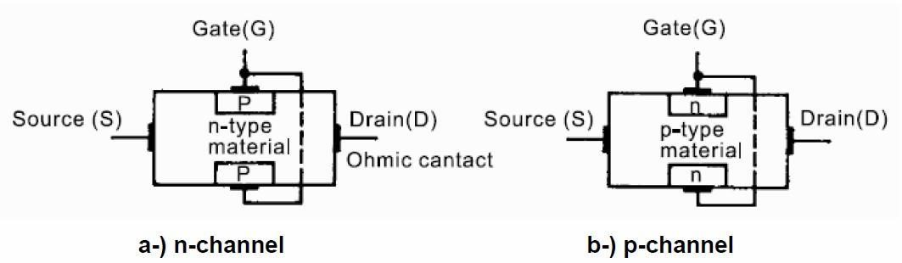

Figure-1: Internal structure of n-channel and p-channel JFETs

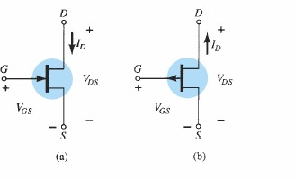Figure 1 depicts the JFETs' internal structure. One pair of p-type regions are diffused into a slab of n-type material to create the n-channel JFET. Instead, one pair of n-type regions are diffused into a slab of p-type material to create the p-channel JFET.

.

Figure 2: JFET symbols: (a) n-channel (b) p-channel

The p -channel JFET is constructed in the same manner as the n -channel device of but with a reversal of the p - and n -type materials. The defined current directions are reversed, as are the actual polarities for the voltages VGS and VDS. For the p -channel device, the channel will be constricted by increasing positive voltages from gate to source and the double-subscript notation for VDS will result in negative voltages for VDS on the characteristics of figure 3, which has an IDSS of 6 mA and a pinch off voltage of VGS = +6 V.

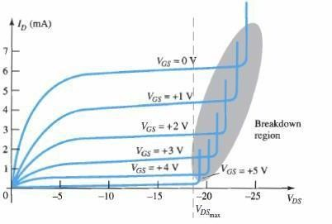

Figure 3: p-channel JFET drain -source characteristics with IDSS = 6 mA and VP = +6 V

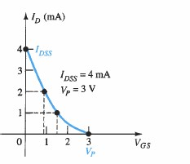

Figure 4: Transfer characteristics of p-channel JFET with IDSS = 4 mA and VP = +3 V

## MOSFETs Structure and Operation

The MOSFETs are the most widely used FETs. Strictly speaking, MOSFET devices belong to the group of Insulated Gate Field Effect Transistor (IGFETs). As the name implies, the gate is insulated from the channel by an insulator. In most of the cases, the insulator is formed by a silicon dioxide (SiO2), which leads to the term MOSFET. MOSETs like all other IGFETs has three terminals, which are called Gate (G), Source (S), and Drain

(D). In certain cases, the transistors have a fourth terminal, which is called the bulk or the body terminal. In PMOS, the body terminal is held at the most positive voltage in the circuit and in NMOS, it is held at the most negative voltage in the circuit.

There are four types of MOSFETs: enhancement n-type MOSFET, enhancement p-type MOSFET, depletion ntype MOSFET, and depletion p-type MOSFET. The type depends whether the channel between the drain and source is an induced channel or the channel is physically implemented and whether the current owing in the channel is an electron current or a hole current. If the channel between the drain and the source is an induced channel, the transistor is called enhancement transistor. If the channelbetween the drain and source is physically implemented, then the transistor is called depletion transistor. If the current owing in the channel is an electron current, the transistor is called an n- type or NMOS transistor. If the current flow is a hole current, then the transistor is called p-type or PMOS transistor. Throughout the handout, we will concentrate on analyzing the enhancement type MOSFET. The cross section of an enhancement NMOS transistor is shown in figure 5. If we put the drain and source on ground potential and apply a positive voltage to the gate, the free holes (positive charges) are repelled

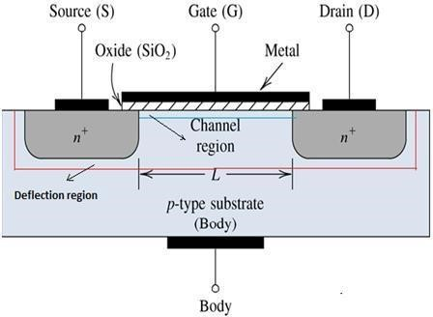

Figure 5: Schematic cross section of an enhancement-type NMOS transistor

from the region of the substrate under the gate (channel region) due to the positive voltage applied to the gate. The holes are pushed away downwards into the substrate leaving behind a depletion region. At the same time, the positive gate voltage attracts electrons into the channel region. When the concentration of electrons near the surface of the substrate under the gate is higher than the concentration of holes, an n-region is created, connecting the source and the drain regions.

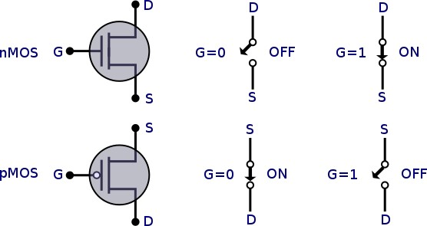

Figure 6: Symbols for Enhancement NMOS and PMOS transistors

The induced n-region thus forms the channel for current flow from drain to source. The channel is only a few nanometers wide. Nevertheless, the entire current transport occurs in this thin channel between drain and source. Now if a voltage is applied between drain and source electrodes an electron current can flow through the induced channel. Increasing the voltage applied to the gate above a certain threshold voltageenhances the channel. In the case of an enhancement type NMOS transistor the threshold voltage is positive, whereas an enhancement type PMOS transistor has a negative threshold voltage. So, in order for the current to flow from drain to source, the condition that should be satisfied is VG > Vth, where VG is the gate voltage and Vth is the minimum voltage required to form a channel between drain and source so that carriers can ow through the channel. By changing the applied gate voltage, we can modulate the conductance of the channel.

Depletion type MOSFETs use a different approach. The channel is already conductive for gate voltages of 0V. Such kinds of MOS transistors are realized by the physical implantation of an n-type region between the drain and the source.

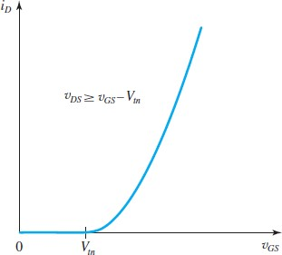

Figure 7: Drain current ID vs gate to source voltage VGS graph of an enhancement type NMOS showing

threshold voltage Vtn

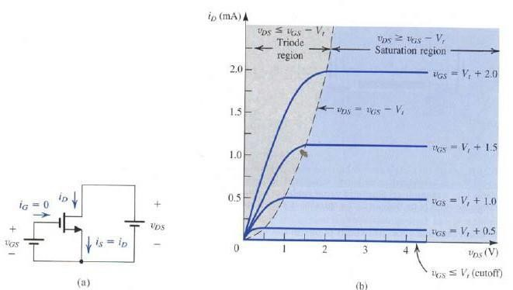

Figure 8: (a) an n-channel enhancement type MOSFET with vGS and vDS applied (b) the iD – vDS characteristics of a device with k’n(W/L) = 1 mA/V2 showing the three operating region.

**Apparatus:**

1. Multimeter
2. J 176 (p-channel JFET)
3. 2N7000 (n-channel enhancement type MOSFET) (4) Connecting wires.

(5) Trainer Board

**CIRCUIT DIAGRAM:**

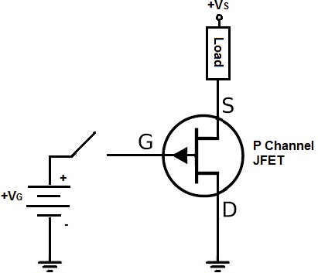

Figure 9: Circuit for plotting ID vs VD and transfer characteristics of p-channel JFET (J176)

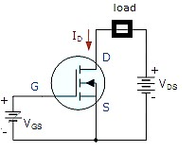

Figure 10: Circuit for plotting ID vs VD and transfer characteristics of p-channel JFET (J176)

**EXPERIMENTAL DATA**:

**TABLE 1 TABLE 3**

|  |  |  |
| --- | --- | --- |
| **VG** | **VGS(V)** | **I D (mA)** |
| 0 | 0.61 | 8.67 |
| 1 | 0.55 | 7.99 |
| 2 | 0.24 | 7.73 |
| 3 | 0.374 | 6.88 |
| 4 | 0.47 | 6.05 |
| 5 | 0.488 | 6.02 |
| 6 | 0.5 | 4.33 |
| 7 | 0.508 | 3.24 |
| 8 | 0.659 | 2.67 |
| 9 | 0.822 | 2.14 |
| 10 | 1.002 | 0.98 |
| 11 | 1.06 | 0.26 |
| 12 | 2.329 | 0.02 |
| 13 | 3.05 | 0.02 |
| 14 | 4.44 | 0.01 |
| 15 | 5.02 | 0.01 |
| 16 | 6.36 | 0.01 |

|  |  |
| --- | --- |
| **VGS(V)** | **I D (mA)** |
| 0 | 0.03 |
| 1 | 0.03 |
| 2 | 4.32 |
| 3 | 4.57 |
| 4 | 4.62 |
| 5 | 4.73 |
| 6 | 4.74 |
| 7 | 4.77 |
| 8 | 4.77 |
| 9 | 4.78 |

Table-1: ID vs VGS curve

Table-3: ID vs VGS curve

**SIMULATION:**

**TABLE-1:**

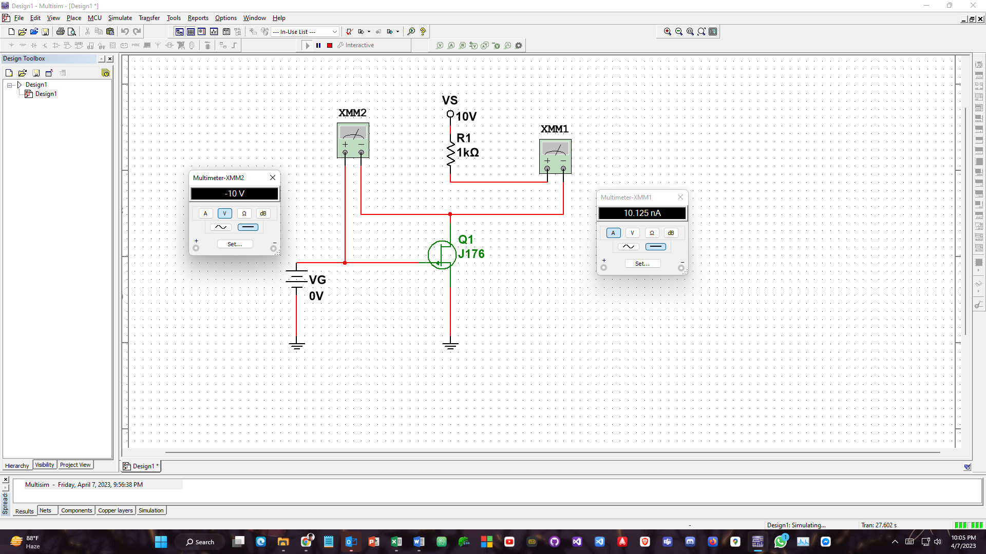...

**TABLE-3:**

